COMPANIES LOGO

**2021.AI**an algorithmic and technology company

**Nordic Motorhomes**

**By Abdallah, Sheriff, Stefano and Antonia**

Date

5/18/2017

Table of Contents

Project Details 3

Use Cases 4

Use case Diagram 10

# Project Details

Nordic Motorhomes rental is a Danish company that rents out motorhomes. Nordic motorhome rental was founded in 2016 and is situated just outside Copenhagen. So far there are 8 employees but the company is very successful and the two owners expect to hire more people soon.

**Employees**:

4 Sales assistants, 2 Cleaning staff, 1 Auto mechanic, 1 bookkeeper

**The Fleet**

Nordic motor home rental has a fleet of 32 motorhomes available for hire. Nordic motor home rental currently offer 8 different types of motorhomes. These are of various brands and models. Some are small compact campers for 2 persons and others are large with up to 6 beds.

**Prices per day**

The price per day for rent depends on the brand and model of the motorhome.

Apart from the brand and model price per day also depends upon the season. There are 3 seasons: Peak season, Middle Season and Low season.

In peak season the prices for all motorhomes are 60 % higher than prices in the middle season. In middle season the prices for all motorhomes are 30 % higher than prices in the low season.

·       The price per day includes 400 free kilometers per day.

·       Insurance is included in the price.

·       External cleaning is included in the price.

**Pick-up and drop-off points**

Nordic motorhome rental offer delivery of motorhomes to a location that is most convenient for the customers. It is often an airport but it can be any other location for instance a ferry port or a hotel. For pick-up or drop-off outside Nordic motorhome rentals office. Customers will be charged a transfer cost of 0,70€ per kilometer.

**Extras**

To make the trip more enjoyable customers can rent accessories such as bike rack, bed linen, child seat, picnic table and chairs etc.

## Use Cases

**UC#1**

*Fully Dressed Use case*

**Title: Create Booking**

**Actors:** Sales Assistant

**Triggers:**

* The user demonstrates that they want to create a booking to rent a motorhome for a customer

**Preconditions:**

* User creates the booking for customer

**Post-conditions:**

* The booking will be placed in the system.
* The user will have registered customer’s details.
* The user will know the dates, motorhome type and customer booking details

**Main success Scenario**:

1. The user will enter the system
2. The system will allow the user to book the dates the customer would like to rent and choose the size of the motorhome
3. The system will present all the available motorhomes for the customer to choose
4. Once the user has chosen the customers desired motorhome, the system will show the details and give the options to add extras.
5. The user will confirm with the customer and input their details (title, name, email, number and pick up and drop off location)
6. System calculates price for the booking.
7. Once the user has updated, the user will input the customer's payment details.
8. The user will confirm on the system that the order information is accurate.
9. The system will submit the order to the completion of the booking.
10. The billing system will confirm that the charge has been placed for the booking.
11. The system will indicate to the user that the booking has been completed and send a confirmation to the customer's email.
12. Once updated the system will present the customers booking details and the contract file attachment where it will give the option to preview, download and print it.
13. The user will exit the system.

**Alternate Flow:**

The customer’s billing information does not process.

The user will confirm with customer that the billing information is correct.

1. The user will input the customer's billing information into the system
2. The system will validate the billing and shipping information.
3. The system will return to use case step 9.

Noun list: dates, size (vehicle type), motorhome, available motorhomes, desired motorhome, extras (bike racks etc.), customer details, pick up & drop off location, payment details, price, (accurate) order information, billing system, charge(placed), booking, confirmation, contract file, user, system

Verb list: enter (log in), book (browse), choose, rent, present (display), add, confirm, input, calculate, submit, place, indicate(charge), completed, send, present (compose contract), exit (logout), preview, download, print

**UC#2**

**Title: Edit/Update Booking**

**Actors:** Sales Assistant

**Triggers:**

* The customer wants to make changes to his reservations

**Pre-conditions:**

* Customer already has a reservation.

**Post-conditions:**

* The reservation will be updated.
* The payment will be updated.
* A new contract will be available.

**Main success Scenario**:

1. Salesman logs on System
2. Salesman selects the reservation in question
3. Salesman makes the changes the customer asked for.
4. Salesman informs the customer of the new price & asks for confirmation
5. Salesman confirms the changes & payment is updated.
6. Salesman prints out the new contract.

**Alternate Flow:**

Customer wants to undo changes

1. Salesman undoes the changes
2. System is back to step 4

The changes the customer asked for can’t be made

1. Salesman informs the customer that changes can’t be made & asks if customer want to make different changes or keep reservation as it is.

The Customer wants to cancel the reservation (doesn’t like new price/changes couldn't be made)

1. Cancel Reservation use case is called

**UC #3**

*Fully Dressed Use case*

**Title: Cancel Booking**

**Actors:** Sales Assistant, Book Keeper

**Triggers:**

* We have a client need that requires the cancellation of a Rental.

**Preconditions:**

* User creates the booking for customer

**Post-conditions:**

* The booking will be placed in the system.
* The user will have registered customer’s details.
* The user will know the dates, motorhome type and customer booking details

**Main success Scenario**:

1. User selects “Rental” option on the welcome (standby) screen.
2. INCLUDE UC: Retrieve Rental
3. Salesman clicks on the Status tab and selects the “cancel and refund” option.
4. INCLUDE UC: Refund
5. System archives rental
6. System confirms the data have been updated.
7. User signs out.

**Alternate Flow:**

The customer’s billing information does not process.

The user will confirm with customer that the billing information is correct.

1. The user will input the customer's billing information into the system
2. The system will validate the billing and shipping information.
3. The system will return to use case step 9.

Noun list: user, “booking” option, welcome screen, “status” tab, “cancel & refund” option, booking

Verb list: select, archive, click, confirm, update, logout

**UC #4**

**Title: Refund**

**Actors:** Sales Assistant, Book Keeper

**Triggers:**

* The user has a need that requires the refund of clients booking.

**Preconditions:**

* User has a valid booking number, or the email of the client concerned.
* User is logged in the System and has loaded the Rentals section from the welcome screen.
* User has localized the booking and has it loaded on the screen.

**Post-conditions:**

* The booking will be placed in the system.
* The user will have registered customer’s details.
* The user will know the dates, motorhome type and customer booking details

**Main success Scenario**:

1. User selects refund option.
2. User selects the payment details that the refund will happen.
3. User confirms that he wants to refund.
4. System archives the payment and confirms the status to the user.

**Alternate Flow:**

Payment method rejected.

The user will try to localize the booking through the client’s history section.

Noun list: “refund” option, payment details, refund

Verb list: select, confirm, refund, archive

**UC #5**

*Fully Dressed Use case*

**Title:** Service and Repair

**Actors:** Service and Repair Team

**Triggers:**

A vehicle is being dropped off by a customer and needs to go through series of checks to determine its roadworthiness.

**Preconditions:**

They check on the system for the vehicle been dropped off.

**Preconditions:**

After the completion of the checks they will determine if the vehicle has passed or failed the inspection.

**Main success Scenario**:

1. The team receives notification of a motorhome been dropped off.
2. They will pick the motorhome up from the drop-off point.
3. The auto mechanic will check the oil, fuel and water.
4. The auto mechanic will inspect the motorhome for roadworthiness.
5. If the motorhome passed the inspection it will be put as passed.
6. The cleaner will then clean the motorhome ready for next customer.

**Alternative Flow:**

1. If the motorhome fails inspection.
2. It will be put as fail on the system.
3. They will notify the sales team and update the vehicle availability status.
4. The mechanic will fix the motorhome and update the system.

Noun List:

Noun list: Vehicles, customer, roadworthiness, system, completion, checks, vehicle, inspection, team, notification, motorhome, dropped off, drop-off point, auto, mechanic, foil, fuel, water, inspection, passed, cleaner, next customer

Verb list; dropped, checks, check, dropped off, passed, failed, receives, pick, passed, failed, inspect, clean, ready, put, notify, fix, update.

**UC #6**

*Fully Dressed Use case*

**Title:** Service and Repair

**Actors:** Service and Repair Team

**Triggers:**

A vehicle is been dropped off by a customer and needs to go through series of checks to determine its roadworthiness.

**Preconditions:**

They check on the system for the vehicle been dropped off.

**Preconditions:**

After the completion of the checks they will determine if the vehicle has passed or failed the inspection.

**Main success Scenario**:

1. The team receives notification of a motorhome been dropped off.
2. They will pick the motorhome up from the drop-off point.
3. The auto mechanic will check the oil, fuel and water.
4. The auto mechanic will inspect the motorhome for roadworthiness.
5. If the motorhome passed the inspection it will be put as passed.
6. The cleaner will then clean the motorhome ready for next customer.

**Alternative Flow:**

1. If the motorhome fails inspection.
2. It will be put as fail on the system.
3. They will notify the sales team and update the vehicle availability status.
4. The auto mechanic will fix the motorhome and update the system.

Noun List: vehicle customer  roadworthiness system  team  motorhome drop-off point auto mechanic oil fuel  water status,notification.

Verb List:  dropped off, checks, completion, passed, failed, receives, pick, inspect, put, clean, ready, update,availability, fix.

**UC #7**

*Casual*

**Title:** Add a new motorhome to the fleet

**Actors:** Bookkeeper

**Triggers:**

A vehicle has been acquired and the company needs to register it in the system

**Preconditions:**

We have all the information about the new vehicle.

**Postconditions:**

The vehicle is added to the fleet and shows up in the System.

**Main success Scenario**:

1. Bookkeeper logs in
2. Bookkeeper is on welcome screen
3. Bookkeeper selects the add new motorhome option
4. Bookkeeper fills in the information of the new motorhome
5. Bookkeeper fills in the number of seats and price of the new motorhome
6. Bookkeeper saves.

**Alternative Flow:** If the bookkeeper enters the wrong information do UC#.. Edit motorhome information.

Noun List: Bookkeeper, welcome screen, motorhome, option, information, number of seats, price

Verb List: logs in, selects, add, fills in, saves.

**UC #8**

*Casual*

**Title:** Edit Motorhome information

**Actors:** BookKeeper

**Triggers:**

There is a reason for the information stored about a Motorhome to be changed, ex. price has changed, color has changed or number of seats has changed.

**Preconditions:**

We have all the new and old information about the vehicle.

**Post-conditions:**

The vehicle is updated on the database, and the new information shows up in the system. Bookings affected by the change should show up on the sales person notification list.

**Main success Scenario**:

1. Bookkeeper logs in
2. Bookkeeper is at the Bookkeeper welcome screen
3. Bookkeeper selects the motorhome to edit and clicks edit
4. Bookkeeper edits the fields where there is new information
5. Bookkeeper clicks save
6. Bookkeeper is back at the welcome screen

**Alternative Flow:** If the bookkeeper enters the wrong information do UC#.. Edit motorhome information.

In the case where the motorhome is already booked in the future, the system notifies the salesperson with the changes made and offers a list of all the upcoming booking affected.

Noun List:

Verb List:

**UC #9**

*Casual*

**Title:** Remove Motorhome

**Actors:** Bookkeeper

**Triggers:**

There is a reason for a motorhome to be permanently removed from the fleet

**Preconditions:**

We have the information of the vehicle.

**Post-conditions:**

The vehicle is updated on the database, and the new information shows up in the system. Bookings affected by the change should show up on the sales person notification list.

**Main success Scenario**:

1. Bookkeeper logs in
2. Bookkeeper is at the Bookkeeper welcome screen
3. Bookkeeper selects the motorhome to edit and clicks edit
4. Bookkeeper edits the fields where there is new information
5. Bookkeeper clicks save
6. Bookkeeper is back at the welcome screen

**Alternative Flow:** If the bookkeeper enters the wrong information do UC#.. Edit motorhome information.

In the case where the motorhome is already booked in the future, the system notifies the salesperson with the changes made and offers a list of all the upcoming booking affected.

Noun List:

Verb List:

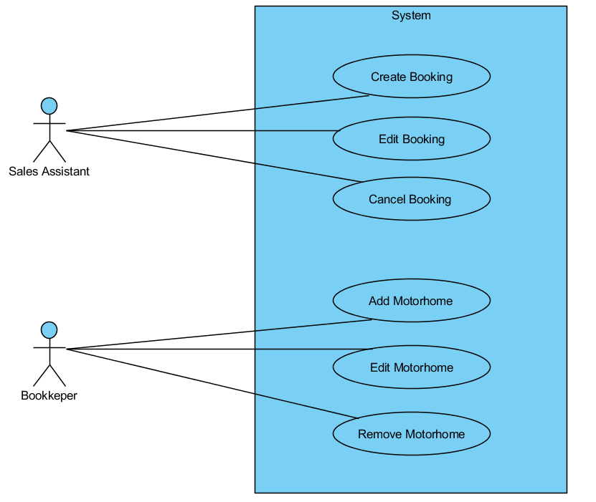

The sale assistant can create, edit and cancel a booking.   
The Book Keep can add, edit and remove motorhomes.

#### Sequence Diagrams

#### 

This sequence diagram shows how the Sales assistant enters the system and makes a booking for the customer.

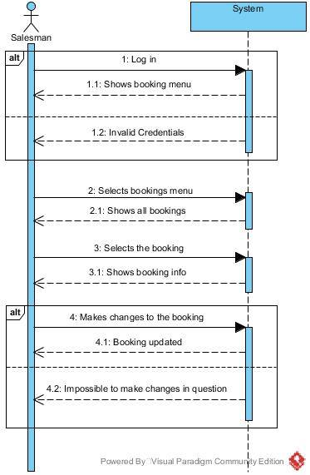

System Sequence to show how the Salesman will access the system and change a previous booking.

##### ITO

**Mission and Purpose**

Nordic Motorhomes rental offers best product and quality motorhomes rental services to its customers with a wide range of choices from brands and sizes.

**Vision**

The company is expecting to hire more employees and increase their vehicles from a fleet of 32 to 64 by 2027 and give their customers more flexibility in terms of picking up points and dropping off points. At some point, they would also like to create an online booking system where customers can rent and choose their own motorhomes.

**Basic information**

Nordic Motorhomes rental is a Danish company that rents out motorhomes. Nordic Motorhomes rental was founded by Bente and Tobias in 2016. They are based just outside of Copenhagen. The company provides motorhomes for rental to its customers at reasonable prices with options of flexible drop off points.

**Operations**

There are 8 employees, 4 Sales assistants, 2 Cleaning staff, 1 Auto mechanic, 1 bookkeeper.

The sales assistants oversee managing and renting motorhomes.

The bookkeeper completes the bookkeeping operations, taxes, banking, payroll and general ledger. He is also the primary contact with financial institutions.

The Auto mechanic oversees vehicle inspections and repairing them.

The cleaning staff clean all the vehicles after they’ve been inspected or repaired.

**Organizational Structure**

Nordic Motorhomes was founded in the Great Copenhagen area by Tobias and Bente Hansen one year ago, in 2016. During this first year, Bente and Tobias have made a large investment in this project -large in relation to their previous experience, before 2016.  This investment has an economical dimension, obtaining a fleet of 32 motorhomes, facilities, marketing and staff, while entrepreneurial projects usually don’t generate any profit within the first five years. Apart of the economical investment they put a considerable capital of personal time, effort, and commitment to the company. During the first year of operations of their start-up, they followed a pre-bureaucratic organizational structure

###### SWOT Analysis

**Strengths**

1. As the company is not based inside Copenhagen they have less competition. They also offer a pick up and drop off in the chosen place of the customer giving the customer less things to worry about.
2. Nordic Motorhomes offers seasonal prices. These prices include 400km travel a day, insurance and external cleaning before and after the motorhome is rented. They also offer a lot of extras to make sure the customer has everything they need when rent the motorhome.
3. They are a small company therefore they can offer a personal touch to each customer. The engage with them from start of booking to end to make sure the customer gets the best experience possible.

**Weaknesses**

1. The system we use could be improved so that customers are able to make, update, delete and view the bookings themselves. If this system is implemented then the company does not need to hire new staff.
2. Competing with competitors inside Copenhagen. If they do this It might mean they must lower their prices resulting in a downfall of overall profit.
3. Weaknesses our market could see is that we do not have an online booking system which customers can use themselves. The customer must contact the company if there are any changes they need to make. This factor could potentially lose them sales as if the office closed or none of their sales team are available for the customer, they will have to wait which will make it troublesome to rent from them.

**Opportunities**

1. Good opportunities would be to implement an online booking system for customer to use.
2. Using social media to advertise vehicles and offers available each season. They could also use more of the internet and make surveys to recognize what their target audiences they look for when renting a motorhome.
3. Giving customers a free day of rental depending on how any days they have rented, aka every week they rent they get one day free, or more extras.
4. Nowadays to rent a motorhome and travel around it is becoming trendy for all ages so they could make opportunities for each age. For example, for younger generation they could offer motorhomes that have colorful decoration inside and out.

Useful opportunities can come from such things as:

**Threats**